**VAJRA KAKSH: STAY SAFE FROM VIRUS**

Sakshi Sharma Ritick Sethi Kuldeep Pandey Prerna Kakkar

ECE, FET ECE, FET ECE, FET ECE, FET

MRIIRS MRIIRS MRIIRS MRIIRS

Faridabad, Haryana, India Faridabad, Haryana, India Faridabad, Haryana, India Faridabad, Haryana, India

[Sakshi24600@gmail.com](mailto:Sakshi24600@gmail.com) [riticksethi8@gmail.com](mailto:riticksethi8@gmail.com) [kp99659@gmail.com](mailto:kp99659@gmail.com) [Prerna.fet@mriu.edu.in](mailto:Prerna.fet@mriu.edu.in)

**Abstract-** **Today the world is suffering from the Covid-19 virus and many other viruses that spread through physical contact, it has driven its way to every part of the world and individuals are fighting for their endurance, yet the dread and spread of Covid do not let individuals go outside their homes and do their day-to-day routine work. Which create a huge loss to one’s earning and not all of them have the facility to work from home which led them to go out into such places which are dangerous and has virus strains. It was the need of the hour to make something like “Vajra Kaksh” which can eliminate the dread of covid-19 from individuals so they can go out to do their everyday work with insurances. The Vajra Kaksh is a sanitizing IOT controlled smart chamber with a touchless system and precautionary measures. This smart chamber offers many applications including ID Card checking through RFID reader and temperature checking of the individual coming into it after that it will check whether the user is wearing a mask or not and then provide them mask and gloves through smart ways after that sanitize the individual and provide them smart id card which will take care of social distancing norm.**

**Keywords- Covid-19 virus, IoT, smart chamber, touchless system, RFID reader, check mask, provide mask, sanitize, smart id card.**

1. INTRODUCTION

The flare-up of the COVID-19 infection has impacted innumerable individuals all over the world. Controlling this real-time pandemic is currently a major priority of the scientific community. People can get infected from the strain of coronavirus in different ways and the most common way of spreading the virus is from one individual to another individual via the spread of contaminated droplets originating from the oral and nasal passages of an infected person, or by being in contact with a contaminated surface. Today, people are living a life, full of fear in their hearts of spreading the coronavirus amongst them and their loved ones. The hunger aspect of human beings has put the people in the situation to come out of their homes and work to earn for the survival of their families. The relaxation in the lockdown leads to a greater number of people coming out from their shelter and getting in contact with such surfaces where there is the presence of coronavirus. Although accidentally, but this has increased their chances of coming in touch with the covid-19 patients, which has led to a tremendous increase in the number of covid-19 patients. Insufficient cleanliness and unhygienic practices can prompt an expansion in the virus spreading rate during this outbreak. The infection is dynamic for as long as three hours in sprayers, as long as four hours on copper surfaces, as long as three days on steel and plastic surfaces, and active up to 24 hours duration on cardboard surfaces. This has made the task of detecting and sanitizing the covid-19 patients amongst people more tedious.

For precautionary measures, people are using sanitizer spraying machines and thermal guns to measure temperature, but it has led to other problems like skin problems due to excessive amounts of chemicals. So to save guard one from such conditions, the best solution is “Vajra Kaksh”- an IoT-powered smart chamber with preventive and required precautionary measures. Technologies used are interfacing with several sensors and using raspberry pi and Arduino for controlling these sensors and making them work systematically

1. **Literature survey:**

Due to the increase in cases of covid-19, a practical based solution should be proposed to save guard people against such diseases. The studies done till date reveal the following points.

F Ahmad, Anima Najam, and Zeeshan Ahmed of Department of CSE, Beijing University of Aeronautics and Astronautics Beijing, 100000, China presented a paper on the topic “image-based face detection and recognition: state of the art”. The main idea of the paper was to evaluate different face detection and recognition methods with higher accuracy, as many public places have surveillance cameras and the human face is dynamic so it becomes difficult to detect the face in computer vision[1]. Akshay Sharma, Department of ECE, from Vidyavardhaka College of Engineering Mysore, India, published a review paper on the topic “Review on Automatic Sanitizer Dispensing Machine” reviewed how an automatic hand sanitization machine works whenever an ultrasonic sensor senses the hand near it, at a distance less than 7cm from the sensor, a 100ms pulse is given from arduino digital output pin. The pump, pumps out some drops of sanitizer, after pumping is done, the distance is again sensed for every 100ms for scanning purposes. Sanitization can be done in different ways which include alcohol sanitization, UV Sanitization, bleach sanitization, Soap Sanitization, etc. The paper also stated that a concentration greater than 70 percent alcohol can kill Coronavirus on hands and how sanitizers are better than liquid and solid soaps[2]. Hurriyatul Fitriyah, Aditya Rachmadi, and Gembong Edhi Setyawan tried to explain by their topic “Automatic measurement of human body temperature on thermal image using knowledge-based criteria” that Instead of using a thermometer, an infrared camera can be used to scan body temperature in real time, without touching anything. The paper proposed that an automatic algorithm can be used to measure the human body temperature with the help of a thermal camera. The camera will capture the infrared radiation that are emitted by the object using a microbolometer sensor. The infrared radiation gives the temperature of the object[3]. Suthaghar S, Augustina Shaglin, Benita, Banapriya, and Beulah explained a smart surveillance camera using Raspberry Pi and OpenCV They have used a low-cost security system that has raspberry pi 2 operating at a speed of 900 MHz and a pi camera. This model can be used for security purposes. The image is captured by a Rpi camera and it is transmit to raspberry pi 2 for processing face and human detection using open cv, after that the detected face is compared with the database and then an audio message is produced and the message is sent to the user. The output of the audio message will depend on the result obtained by a database that whether the person’s face is known or stranger[4]. Naveen Kumar k, suryaS, Mohammed Nihaal, and Manoj Kumar suggested an automatic covid -19 face mask and body temperature detection. A Raspberry Pi 4 Model B to detect face mask protocol violation through an integrated pi Camera and to monitor body temperature with MLX90614 Sensor, A 5MP raspberry pi camera module is used for this setup and The MLX90614 is an infra-red thermometer for non-contact temperature machine .it has a range of -20 c to 120 c, they are smart enough to check temperature and face mask at the time and alert the respective authorities to take necessary action if the protocol is not followed[5].

**3 TECHNICAL DESCRIPTION**

Raspberry pi camera, ultrasonic sensor, thermal sensor, and DC motor with conveyor belt are integrated to create a system that is of medical benefit, used in today’s practical scenario and utmost need of contact-free as well as the virus-free environment

**3.1 Block Diagram of RFID Tag**

RFID Reader

RFID Tag

Radio waves

Fig 1: Interaction of RFID reader

When a person enters into the chamber then he has to punch his RFID Tag on the RFID reader present in the chamber, the tag will act as a unique login credential that indicates that this user is a member of the respective organization.

**3.2 Flow Chart of Chamber:**

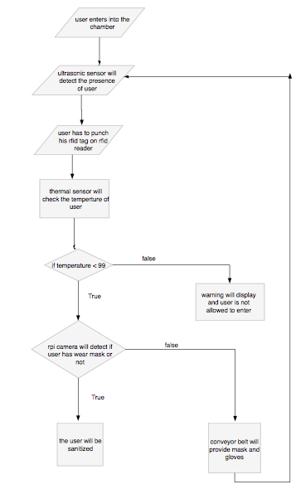

Fig 2: Working of flowchart

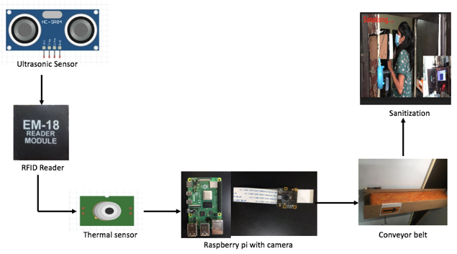

Fig 3: Working of Chamber

* The ultrasonic sensor will detect the presence of a person inside the chamber.
* The person has to punch his RFID tag on the reader, if the tag is approved then the process will move forward.
* The thermal sensor will check the temperature of the person, if the temperature of the user is found above the normal limits i.e. above 99 degrees, then a message will be displayed that “you are not allowed to enter”, and the person will get to know that his temperature is beyond normal, and the user is not allowed to enter in the premises.
* If the temperature of the user is found normal i.e below 99 degrees, then the Rpi camera will detect whether the user has worn the mask or not.
* If the user has not worn the mask then the camera will detect it and the process will trigger the conveyor belt. The Conveyor belt will contain the masks and gloves for the users and the user has to wear a mask and gloves and user has to start the process again by punching the RFID tag.
* If the user is wearing a mask then he is safe to move forward.
* There will be a shower of sanitizer on the user through nossels.

3.3 **Architecture of Chamber:**



Fig 4: Architecture of chamber

3.4 Working of ID Card

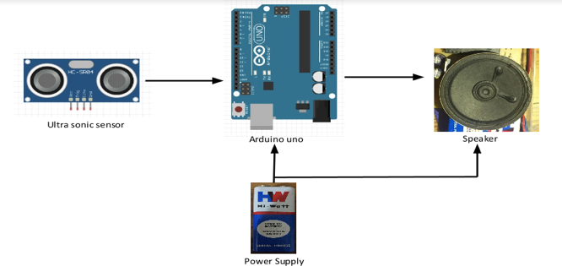

Fig 5: Block Diagram of ID Card

* The user needs to wear an IoT-powered ID card that contains an ultrasonic sensor.
* The sensor relates to an Arduino and a speaker is connected to the output of Arduino.
* The sensor will detect if a person is in a range of 2 meters or not, if it detects the presence of a human being near the user then the speaker will start beeping and indicate the users to maintain distance.

**3.5 Flow Chart of Social Distancing ID Card:**



Fig 6: flowchart for ID card.

**4 . Hardware used:**

* **RFID Reader:** A radio frequency identification reader is used to gather information from an RFID tag. Mostly it is used to track objects. Radio waves are used to gather the data from the tag to a reader. The RFID tag should be in range of an RFID reader, which is from 3-300 feet. The Frequency ranges from low frequencies of 125-134 khz and high frequencies of 850 to 950 MHz. Wavelengths in the 2.4 GHz **[Fig 7]**



Fig 7: RFID Reader

* **Thermal Sensor:** It is an electronic device that is used to measure the temperature and converts the input data into electronic data. The sensor consists of two metals, that generates electrical voltage whenever they sense a change in temperature**. [Fig 8]**

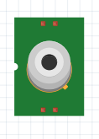

Fig 8: Thermal Sensor

**Raspberry pi & pi camera:** Raspberry Pi is the most commonly used microcontroller. While designing applications this board is preferred as it is low priced and has a small CPU that can be connected with any monitor or television by attaching an external keyboard and mouse in its dedicated ports. It is an open-source platform and can be easily accessed. RPI camera is a high-quality 8MP image sensor added on raspberry pi with the feature of a fixed focus lens. Its pixel frame rate is 3280 x 2464 and supports 1080p30 and below video quality **[Fig 9]**

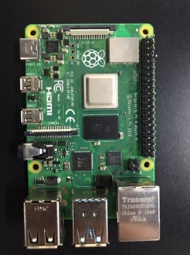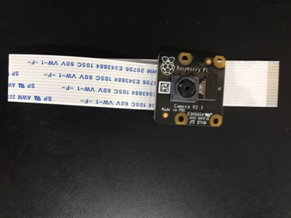

Fig 9: Raspberry pi & pi camera

* **dc Induction motor-**It is a rotating device that converts direcr current into mechanical energy. Rotatory motion is developed when the inductor inside the motor creates a magnetic field on applying DC voltage. The shaft of the motor is wrapped with a coil of wires and contains two fixed magnets on both sides producing repulsive and attractive force and creating torque. **[Fig 10]**

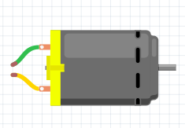

Fig 10: dc Induction motor

* **Belt for Conveyor-** Belt conveyors are the most used conveyors as they are very versatile and less expensive. Belt conveyor consists of two or more than two pulleys with a closed loop of carrying medium that rotates about them. One or both pulleys are powered, moving the belt and the material on the belt forward The very essential tool of the project is the conveyor belt commonly used in the material handling sector. It is made up of stripes that are constantly moving and carrying stuff from one place to another.**[Fig 11]**

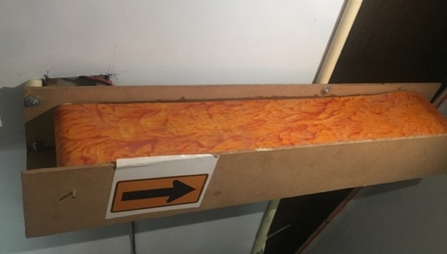

Fig 11: Belt for conveyor

* **Nozzles for spray:** The spray nozzle transforms the energy of a liquid into kinetic energy. The kinetic energy is utilized to break the liquid into little particles and to disperse them evenly according to the desired pattern. The capacity relies on the internal flow area and the functioning pressure. They are accessible in a wide range of designs suitable to tackle any kind of spray problem. **[Fig 12]**

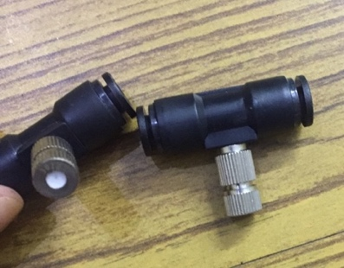`

Fig 12: Nozzles for spray

* **Arduino Uno:** It is the main microcontroller functioning on a [Microchip](https://en.wikipedia.org/wiki/Microchip_Technology)  [ATmega328P](https://en.wikipedia.org/wiki/ATmega328P)  microcontroller. It is an open-source microcontroller that is programmable. It has different pins that can be used for connecting other sensors.**[Fig 13]**

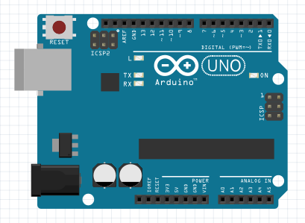

Fig 13: Arduino Uno

**Ultrasonic sensor:** It is an electronic device that measures the distance of an object by emitting ultrasonic waves and the reflected wave are converted to produce an electrical signal. Ultrasonic waves travel quicker than the speed of perceptible sound. It measures the distance of the targeted object by estimating the time between the emission and reception for ultrasonic sensing. The most widely used range is 40 to 70 kHz. **[Fig14]**

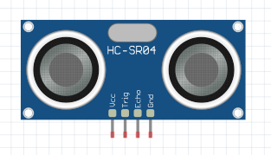

Fig 14: Ultrasonic sensor

* **Speaker:** These are the transducers that change electromagnetic waves into sound waves**.** The speakers are ostensibly the main key component as they are responsible for making a clear and understandable message that will be perceived by the listener. **[Fig 15]**

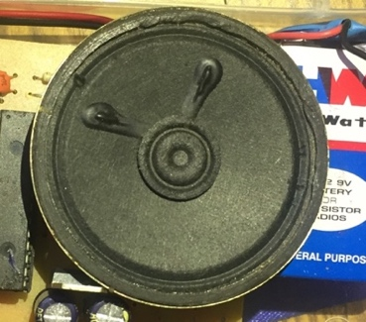

Fig 15: Speaker

* **Rpi screen:** The Raspberry Pi Touch Display is an LCD that connects to the Raspberry Pi through the DSI connector. It is used to display messages to the user. **[Fig 16]**

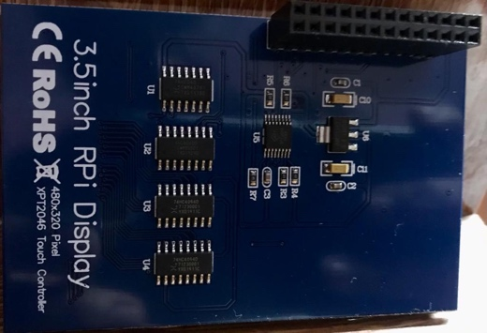

Fig 16: Rpi screen

1. **FUTURE SCOPE**

In this current situation, many offices are reopening but because of the fear of getting coronavirus, employees can not get back to work properly. The benefit of solving this challenge is that people will able to work fearlessly by keeping sanitization and other safety measures into consideration. This chamber has the potential to attract most of the offices, organizations, workplaces, schools, colleges, etc that are in the seek of getting reopen but are grasped by the issues of maintaining sanitization and social distancing among the staff. With the features of human body temperature study, face mask and glove as well as sanitization, and id cards for maintaining proper distance. It will become a fully-featured model for the sanitation and detection issues. It will reduce the fear among offices about corona spread in the office and the number of corona cases in the workplaces can be reduced to a great extent by using this chamber.

1. **CONCLUSION**

After going through all the above-mentioned papers and solutions available in the market, we came to know that the current solutions are working great, but the need for the current scenario is social distancing and a device that can detect the temperature and check whether the user is wearing a mask or not and ensure that, the staff is following the norms by maintaining proper sanitization and social distancing. The technology is growing with the current situation of pandemic and keeping in mind, the future scope of viruses, we have created a complete solution which is an IoT powered smart chamber that can contribute in taking precautionary measures against different types of viruses. It will help in the sanitization, measuring body temperature, maintaining social distance, and providing masks and gloves to the user entering into it. The chamber can be installed in offices, schools, colleges, and other workplaces. It is taking care of two main preventive measures that are sanitization and social distancing. This will contribute to the health care department in fighting against novel coronavirus.

1. **REFERENCES**

[1] Ahmad, F., Najam, A. and Ahmed, Z., 2013. Image-based face detection and recognition:" state of the art". *arXiv preprint arXiv:1302.6379*

[2]<https://www.researchgate.net/publication/343056110_Review_on_Automatic_Sanitizer_Dispensing_Machine>

[3] <https://www.ijert.org/review-on-automatic-sanitizer-dispensing-machine>

[4]<https://www.researchgate.net/publication/272377461_Review_of_industrial_temperature_measurement_technologies_and_research_priorities_for_the_thermal_characterisation_of_the_factories_of_the_future>

[5]https://www.researchgate.net/publication/321505136_Automatic_Measurement_of_Human_Body_Temperature_on_Thermal_Image_Using_Knowledge-Based_Criteria

[6] [Pandya, S.](https://www.emerald.com/insight/search?q=Sharnil%20Pandya), [Sur, A.](https://www.emerald.com/insight/search?q=Anirban%20Sur) and [Kotecha, K.](https://www.emerald.com/insight/search?q=Ketan%20Kotecha) (2020), "Smart epidemic tunnel: IoT-based sensor-fusion assistive technology for COVID-19 disinfection", [*International Journal of Pervasive Computing and Communications*](https://www.emerald.com/insight/publication/issn/1742-7371), Vol. ahead-of-print No. ahead-of-print. <https://doi.org/10.1108/IJPCC-07-2020-0091>

# [7] Disinfection tunnels: potentially counterproductive in the context of a prolonged pandemic of COVID-19 by [M. Biswal](https://www.ncbi.nlm.nih.gov/pubmed/?term=Biswal%20M%5BAuthor%5D&cauthor=true&cauthor_uid=32422441),∗ [R. Kanaujia](https://www.ncbi.nlm.nih.gov/pubmed/?term=Kanaujia%20R%5BAuthor%5D&cauthor=true&cauthor_uid=32422441), [A. Angrup](https://www.ncbi.nlm.nih.gov/pubmed/?term=Angrup%20A%5BAuthor%5D&cauthor=true&cauthor_uid=32422441), and [P. Ray](https://www.ncbi.nlm.nih.gov/pubmed/?term=Ray%20P%5BAuthor%5D&cauthor=true&cauthor_uid=32422441)(Department of Medical Microbiology, Post Graduate Institute of Medical Education and Research (PGIMER), Chandigarh, 160012, India) June 2020.<https://www.ncbi.nlm.nih.gov/pmc/articles/PMC7200329/>

# [8] <https://www.ijeat.org/wp-content/uploads/papers/v9i4/D7914049420.pdf>

[9] Hoang, M.L., Carratù, M., Paciello, V. and Pietrosanto, A., 2021. Body Temperature—Indoor Condition Monitor and Activity Recognition by MEMS Accelerometer Based on IoT-Alert System for People in Quarantine Due to COVID-19. *Sensors*, *21*(7), p.2313

.